**REPORT SUBMISSION SHEET**

**Please follow these instructions carefully**

Add your URN and report subject and upload this page as the first page of your report submission to SurreyLearn to the Report folder in the Assignments tab by

**17:00 on Thursday March 16th**

Please upload three copies of the report (each containing this cover sheet). The file name of the **Word** documents you upload must be your URN, followed by a space, a dash and a space, then “report” plus the letter A, B or C. **It is very important that you follow these instructions exactly**. This is to ensure confidentiality at all stages of the peer review process.

Thus if your URN is 9008708 the title of your three documents will therefore be

**“9008708 - reportA.docx”, “9008708 - reportB.docx” and “9008708 - reportC.docx”**

Do **not put your name** anywhere on your report, either in the body of the text, the title or any headers or footers.

**Do not upload the document as a pdf or in any other format than Word.**

You need to delete any references to authorship in order to maintain anonymity.  In your Word document click on **File**, in the **Info** page which comes up click on **Check for Issues** and then **Inspect Document**.  On the **Document Inspector** dialog box click **Inspect**.  Word will check the document and a box will come up headed **Document Properties and Personal Information**. Click on **Remove All** and then click **Reinspect**.  Continue to click on any other **Remove All** buttons which appear and once more click **Reinspect.** Then click on **Save.**

These steps will ensure that your report can be given anonymously to the three peer reviewers and that every document is uniquely identified in the marking process. You will receive feedback, anonymously from each of the three reviewers.

6321340

**URN**

**REPORT SUBJECT**

The major voting systems in use around the world

***Late Submission***

*If you do not submit your report by the deadline specified and there are no confirmed extenuating circumstances,* ***the mark awarded will be reduced by 10 percentage points for each 24 hour period after the deadline, up to and including the third day after the submission*** *(30 percentage points).  Therefore, if the mark were 80%, but the report was submitted 30 minutes past the deadline, you would be awarded a mark reduced by 10% to 70%. The mark recorded for a* ***report submitted******after 10am on Thursday 21st April is zero****.  The same penalties will apply to the peer review submissions. If you have not submitted a report you will not participate in the peer review process and will receive a zero mark for this piece of work.*

**The Major Voting Systems in use around the World**

There is a plethora of electoral systems in use to elect Parliaments around the world. We will explore the most popular electoral systems in this report and briefly comment on the fairness of these systems.

* First past the post (FPTP)
* Party list proportional representation (PR)
* Two-round run-off
* Additional-member system (AMS)
* Alternative Vote (AV)

First past the Post

First past the post is one of the most popular voting systems around the world, especially within countries formerly part of the British Empire [10]. It is used in the UK, USA, India, Canada, and a variety of other countries [10]. FPTP demands that the nation is divided into constituencies. Each constituency returns one member to Parliament. Hence, there are only as many members taking seats in Parliament as there are constituencies in the country.

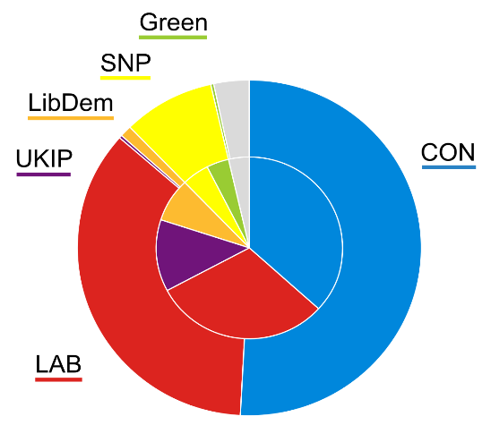  
On polling day, the electorate is given a list of candidates standing for election in their constituency. An individual may only choose one candidate to vote for. After polling stations close, the votes are subsequently counted and the candidate with the most votes wins and is sent to Parliament. Therefore, all other candidates lose and are not sent to Parliament; this leads to some dubbing this system “winner takes all” [2].

The popular vote for a party is defined as the total number of votes won by all the candidates who stood for the same party. Since losers are given nothing, nor is there a minimum vote the winner must achieve, this can lead to Parliaments where one party may have a majority of seats but a minority of the popular vote. This happens because the party that won the election, fielded candidates who defeated all alternative candidates in a majority of constituencies in the country. Thus, proportionality is traded for local accountability.

*Pie chart [11] showing the results from the UK 2015 Westminster elections. Inner circle shows popular vote. Outer circle shows seats won*

Party List Proportional Representation

Party list PR is popular in the European Mainland, Latin America, and sub-Saharan Africa [7]. Unlike FPTP, the country does not need to be divided into constituencies. However, constituencies do exist in some countries such as Spain [5]. Political parties are required to produce ranked lists of candidates that they would like to sit in Parliament.

On polling day, the electorate is then given the right to choose their favourite list of candidates and may vote for one respectively. There are several different ways to count votes, here we will look at a commonly used method which is the **d'Hondt method**[8]. First, the total votes are tallied and divided by the number of seats won by the party (either in the constituency or the entire nation) plus one to acquire a number for the quota for each party. Obviously, at the beginning of the counting process every party has zero seats.

$$Quota=\frac{Total votes}{Number of seats won by party+1}$$

Under the **d'Hondt** counting system, the party which has the largest quota has its 1st member of the list granted a seat in Parliament and they are duly elected. Then the quota for that party is adjusted thereafter and the party with the largest quota is sought after again. This process is repeated, so ensuring a level of proportionality of seats won to votes cast for those parties. It also ensures that the leadership of all the parties are entrenched in Parliament since the leadership put themselves at the top of the list [1]. Here local accountability is exchanged for proportionality.

Two-Round Run-off

Two-round run-off systems are very similar to first past the post. The President of the 5th French Republic is elected this way. Like FPTP, the country is divided into constituencies and each constituency elects one MP from a list of candidates standing there. The election is split into two polling days usually a week apart.

On the 1st polling day, voters vote for their favourite candidate. If no-one receives more than 50% of the total vote in the first round [4], then the two most popular candidates are selected to stand for election again in the 2nd round. All candidates who win over 10% may stand in the 2nd round [14]. The winner of the 2nd round is then returned to Parliament, with the loser of the 2nd round facing the same fate as those who didn’t make it to the 2nd round. A major consequence of two-round is establishment parties collaborating with each other in the 2nd round to cut down minor parties. They do this by standing down and letting a less disagreeable opponent win [13].

Additional-Member System

Additional-Member systems are a mixture of first past the post and party lists. The most well-known Parliaments which are elected using AMS are the Scottish Parliament and the German Bundestag. The nation is divided into constituencies and each of these constituencies belong to one region each e.g. all the Glasgow constituencies belong to the Glasgow region. Each constituency returns one member to the Parliament, just as it would do under FPTP. In addition to those MPs, more are elected from a top-up list which operates under the **d’Hondt** system.

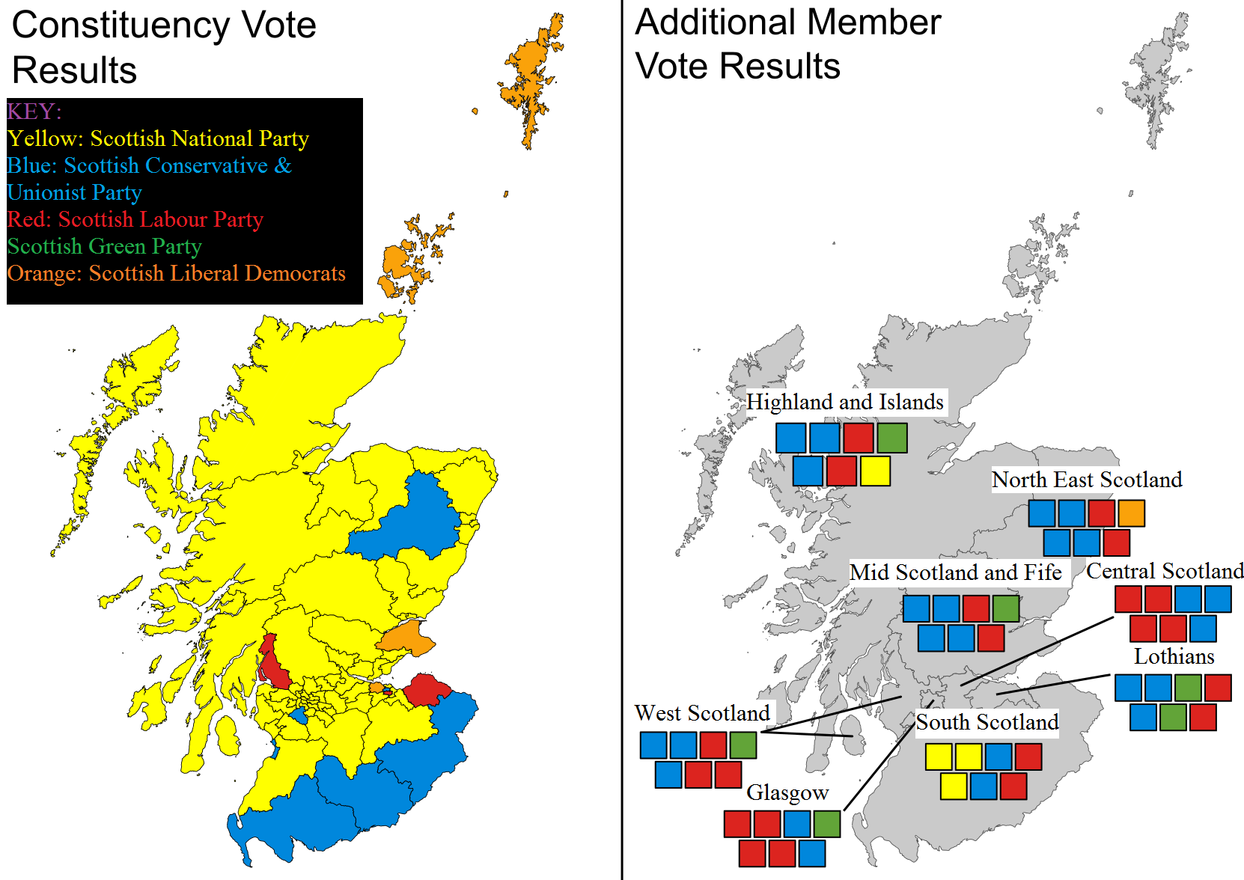

*Scottish Parliamentary election results for 2016 with constituency results on the left and regional list results on the right* [12]

On polling day, individuals from the electorate are provided two ballots each. One for their constituency and one for their region. They then choose their favourite candidate to represent their constituency and then their favourite party list for the region. Constituency seats are allocated using FPTP. The distribution of regional seats operates under the **d’Hondt system**. Constituency seats won in that region as well as regional seats are used to find the quota. Therefore, there are two classes of politicians: one which was directly elected by a locality and another which was elected from a list for a region [3].

Alternative Vote

AV is used to elect the Australian House of Representatives [6]. AV is like first past the post insofar as the country is divided into constituencies and each constituency elects one MP from a list of candidates.

On polling day, voters are then able to rank candidates in numerical order with lower numbers indicating higher preference. Voters are free to rank as many as they please. The votes are then tallied and if no candidates win over 50% of the 1st preference votes, then the candidate with the fewest votes is eliminated. That candidate’s votes are redistributed per their 2nd preferences. This process repeats (using 3rd, 4th, etc. preference votes) until a candidate breaches the 50% threshold, therefore winning a seat in Parliament. This system was devised to stop the ‘spoiler effect’ found in FPTP elections [9].

From the wide variety of electoral systems in use around the world, not only is democracy widespread but the people want different things from their electoral systems. FPTP offers direct accountability of politicians but party list PR gives proportionality of seats won to votes cast. Whilst others try to create a compromise between proportionality and local accountability. So, we can conclude that fairness in elections implies different things to different electorates and nations.

## **References**

1. aceproject.org. (2017). *Advantages and disadvantages of List PR —*. [online] Available at: http://aceproject.org/ace-en/topics/es/esd/esd02/esd02c/esd02c01 [Accessed 14 Mar. 2017].
2. British Broadcasting Corporation (2017). *BBC - Higher Bitesize Modern Studies - Electoral systems, voting and political attitudes: Revision*. [online] Available at: http://www.bbc.co.uk/bitesize/higher/modern/uk_gov_politics/elect_vote/revision/1/ [Accessed 14 Mar. 2017].
3. Direct Party and Representative Voting (2017). *FPTP compared*. [online] Available at: http://www.dprvoting.org/FPTP_comparison.htm [Accessed 14 Mar. 2017].
4. Electoral Reform Society (2017). *The Two Round System*. [online] Available at: http://www.electoral-reform.org.uk/two-round-system [Accessed 14 Mar. 2017].
5. Wikipedia (2017). *Congress of Deputies (Spain)*. [online] Available at: https://en.wikipedia.org/wiki/Congress_of_Deputies_(Spain) [Accessed 14 Mar. 2017].
6. Wikipedia (2017). *Instant-runoff voting*. [online] Available at: https://en.wikipedia.org/wiki/Instant-runoff_voting#Australia [Accessed 14 Mar. 2017].
7. iforindiaorg.files.wordpress.com (2017).  [online] Available at: https://iforindiaorg.files.wordpress.com/2014/09/electoral.png [Accessed 14 Mar. 2017].
8. Scottish Parliament Website (2017). *The Additional Member System - Calculating the Regional Results guidance*. [online] Available at: http://www.parliament.scot/visitandlearn/Education/65978.aspx [Accessed 14 Mar. 2017].
9. thecrimson.com (2017). *Beware The Spoiler Effect | Opinion | The Harvard Crimson*. [online] Available at: http://www.thecrimson.com/article/2012/10/30/third-party-spoiler/ [Accessed 14 Mar. 2017].
10. Wilkinson, M. (2017). *What is the First Past The Post voting system?*. [online] Telegraph.co.uk. Available at: http://www.telegraph.co.uk/news/general-election-2015/11452839/What-is-the-First-Past-The-Post-voting-system.html [Accessed 14 Mar. 2017].
11. Wikipedia (2017). *First-past-the-post 2015.svg*. [online] Available at: https://en.wikipedia.org/wiki/File:First-past-the-post_2015.svg [Accessed 14 Mar. 2017].
12. Wikipedia (2017). [online] Available at: https://upload.wikimedia.org/wikipedia/commons/thumb/d/d1/Scottish_Election_Results_2016.svg/1662px-Scottish_Election_Results_2016.svg.png [Accessed 14 Mar. 2017].
13. British Broadcasting Corporation (2016). *French National Front defeated in bid to win regional vote - BBC News*. [online] Available at: http://www.bbc.com/news/world-europe-35088276 [Accessed 14 Mar. 2017].
14. Wikipedia (2017). *French regional elections, 2015*. [online] Available at: https://en.wikipedia.org/wiki/French_regional_elections,_2015 [Accessed 14 Mar. 2017].